1.1. Logical scheme
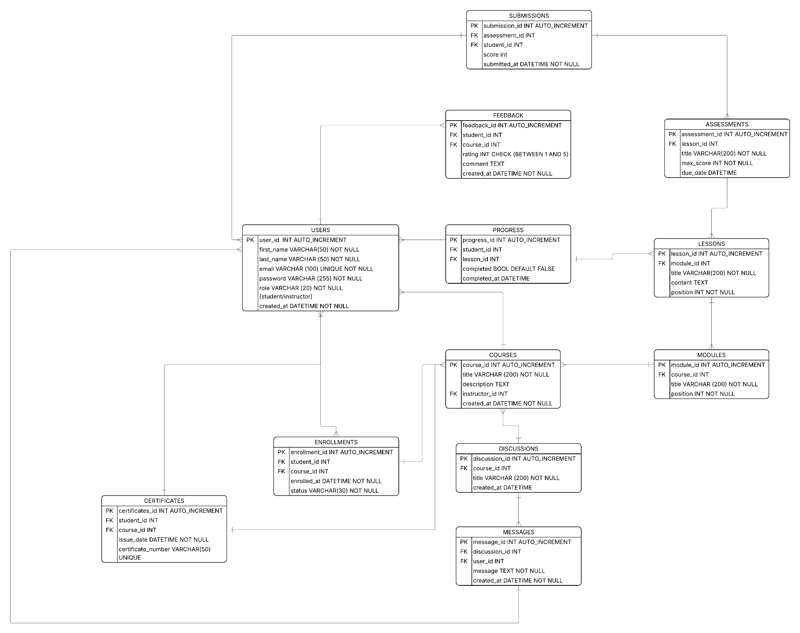

1.2 Objects

Table name: USERS
- Stores information about each user, such as their unique ID, name, email, and registration details.

Field name | Field description | Data type/Constraints
user_id | User’s ID | PK INT AUTO_INCREMENT
first_name | User’s first name | VARCHAR(50) NOT NULL
last_name | User’s last name | VARCHAR(50) NOT NULL
email | User’s email | VARCHAR(100) UNIQUE NOT NULL
password | User’s email password | VARCHAR(255) NOT NULL
role | User’s role | VARCHAR(20) NOT NULL (student/instructor)
created_at | Date when user created their account | DATETIME NOT NULL

Table name: COURSES
- Stores information about courses, including their title, description, instructor, and creation date.

Field name | Description | Data type/Constraints
course_id | Unique ID for each course | PK INT AUTO INCREMENT
title | Name of the course | VARCHAR(200) NOT NULL
description | Details about the course | TEXT
instructor_id | ID of the instructor teaching the course | FK INT
created_at | Date and time the course was created | DATETIME

Table name: PROGRESS
- Stores information about each student’s progress in lessons, including whether a lesson is completed and when it was completed.

Field name | Description | Data types/Constraints
progress_id | Unique ID for each progress record | PK INT AUTO_INCREMENT
student_id | ID of the student | FK INT
lesson_id | ID of the lesson | FK INT
completed | Indicates if the lesson is completed (yes/no or 1/0) | BOOL DEFAULT FALSE
completed_at | Date and time when the lesson was completed | DATETIME

Table name: FEEDBACK
- Stores student reviews and ratings for courses, including comments and submission time.

Field name: | Description | Data types/Constraints
feedback_id | Unique ID for each feedback entry | PK INT AUTO_INCREMENT
student_id | ID of the student giving the feedback | FK INT
course_id | ID of the course being reviewed | FK INT
rating | Score given by the student (e.g., 1–5) | INT CHECK (BETWEEN 1 AND 5)
comment | Optional text comment from the student | TEXT
created_at | Date and time the feedback was submitted | DATETIME NOT NULL

Table name: SUBMISSIONS
- Stores student submissions for assessments, including scores and submission timestamps.

Field name | Description | Data types/Constraints
submission_id | Unique ID for each submission | PK INT AUTO_INCREMENT
assessment_id | ID of the assessment being submitted | FK INT
student_id | ID of the student making the submission | FK INT
score | Score received for the submission | INT
submitted_at | Date and time the submission was made | DATETIME NOT NULL

Table name: ASSESSMENTS
- Stores information about assessments for lessons, including their title, maximum score, and due date.

Field name | Description | Data types/Constraints
assessment_id | Unique ID for each assessment | PK INT AUTO-INCREMENT
lesson_id | ID of the lesson the assessment belongs to | FK INT
title | Name of the assessment | VARCHAR(200) NOT NULL
max_score | Maximum possible score for the assessment | INT NOT NULL
due_date | Deadline for submitting the assessment | DATETIME

Table name: LESSONS
- Stores information about lessons within modules, including their title, content, and order.

Field name | Description | Data type/Constraints
lesson_id | Unique ID for each lesson | PK INT AUTO_INCEREMENT
module_id | ID of the module the lesson belongs to | FK INT
title | Name of the lesson | VARCHAR (200) NOT NULL
content | Material or content of the lesson | TEXT
position | Material or content of the lesson | INT NOT NULL

Table name: MODULES
- Stores information about course modules, including their title and order within a course.

Field name | Description | Data types/Constraints
module_id | Unique ID for each module | PK INT AUTO_INCREMENT
course_id | ID of the course the module belongs to | FK INT
title | Name of the module | VARCHAR(200) NOT NULL
position | Order of the module within the course | INT NOT NULL

Table name: DISCUSSIONS
- Stores course discussion topics, including their title and creation time.

Field name | Description | Data types/Constraints
discussion_id | Unique ID for each discussion | PK INT AUTO_INCREMENT
course_id | ID of the course the discussion belongs to | FK INT
title | Topic or title of the discussion | VARCHAR(200) NOT NULL
created_at | Date and time the discussion was created | DATETIME

Table name: MESSAGES
- Stores messages posted by users in course discussions, including content and timestamp.
Field name | Description | Data types/Constraints
message_id | Unique ID for each message | PK INT AUTO_INCREMENT
discussion_id | ID of the discussion the message belongs to | FK INT
user_id | ID of the user who sent the message | FK INT
message | Text content of the message | TEXT NOT NULL
created_at | Date and time the message was sent | DATETIME NOT NULL

Table name: ENROLLMENTS
- Stores information about students’ enrollment in courses, including enrollment date and current status.

Field name | Description | Data types/Constraints
enrollment_id | Unique ID for each enrollment record | PK INT AUTO_INCREMENT
student_id | ID of the student enrolled in the course | FK INT
course_id | ID of the course the student is enrolled in | FK INT
enrolled_at | Date and time the student enrolled | DATETIME NOT NULL
status | Current status of the enrollment | VARCHAR(30) NOT NULL

Table name: CERTIFICATES
- Stores information about certificates awarded to students for completing courses, including issue date and certificate number

Table name | Description | Data types/Constraints
certificates_id | Unique ID for each certificate | PK INT AUTO_INCREMENT
student_id | ID of the student receiving the certificate | FK INT
course_id | ID of the course for which the certificate is issued | FK INT
issue_date | Date the certificate was issued | DATETIME NOT NULL
certificate_number | Unique number assigned to the certificate | VARCHAR(50) UNIQUE

Table relationships

USERS
user_id | first_name | last_name | email | password | role | created_at
1 | Aiken | Amanbay | aiken@gmail.com | pass123 | student | 2026-03-01
2 | Dias | Yermekov | dias@gmail.com | pass456 | instructor | 2026-03-01

COURSES
course_id | title | description | instructor_id | created_at
1 | Python Basics | Introduction to Python Programming | 2 | 2026-03-02
2 | C#/.NET Development | Learn C#/.NET basics | 2 | 2026-03-02

MODULES
module_id | course_id | title
1 | 1 | Python Introduction
2 | 1 | Python functions

LESSONS
lesson_id | module_id | title | content
1 | 1 | What is Python | Introductory lesson
2 | 1 | Installing Python | Setup Guide

ASSESSMENTS
assessment_id | lesson_id | title | max_score | due_date
1 | 1 | Python Quiz | 100 | 2026-03-10
2 | 2 | Installation task | 50 | 2026-03-11

SUBMISSIONS
submission_id | assessment_id | student_id | score | submitted_at
1 | 1 | 1 | 90 | 2026-03-09
2 | 2 | 1 | 45 | 2026-03-10

ENROLLMENTS
enrollment_id | student_id | course_id | enrolled_at | status
1 | 1 | 1 | 2026-03-03 | active
2 | 1 | 2 | 2026-03-03 | active

PROGRESS
progress_id | student_id | lesson_id | completed | completed_at
1 | 1 | 1 | TRUE | 2026-03-04
2 | 1 | 2 | FALSE | NULL

FEEDBACK
feedback_id | student_id | course_id | rating | comment | created_at
1 | 1 | 1 | 5 | Very useful course | 2026-03-12
2 | 1 | 2 | 4 | Good explanations | 2026-03-12

DISCUSSIONS
discussion_id | course_id | title | created_at
1 | 1 | Python Help | 2026-03-05
2 | 2 | C# questions | 2026-03-06

MESSAGES
message_id | discussion_id | user_id | message | created_at
1 | 1 | 1 | I need help with Python loops!!! | 2026-03-05
2 | 1 | 2 | I will explain in the next lesson | 2026-03-05

CERTIFICATES
certificates_id | student_id | course_id | issue_date | certificate_number
1 | 1 | 1 | 2026-04-01 | CERT-01
2 | 1 | 2 | 2026-04-10 | CERT-002

